

The Bath Duathlon 2025
Race Pack – Sunday 13th April
Welcome
Welcome to the Bath Duathlon 2025, Sunday 13th April. We hope you have a fantastic time and race at Odd Down Bike Circuit. Please read through and understand these race instructions, in order that you have an enjoyable and safe race. There will be a very short race safety briefing at the start of each race and race officials will be on hand to answer questions on the day, but it is your responsibility to understand British Triathlon’s rules of competition and the event specific details.

We are very grateful and would like to thank the following for providing event support, sponsorship, prizes and event logistics plus our amazing volunteer marshals.
Pronto Bikes
U Perform
Splitsecond Timing
TRI-it Intelligent Training
GLL Odd Down Pavillion & Bike Circuit
A2E Event Medics

Venue & Car Parking
Odd Down Bike Circuit & Pavillion
What three words: http://w3w.co/blank.yoga.sport

Odd Down Bike Circuit is located at Odd Down Playing Fields, Chelwood Drive, Bath BA2 2PR
Please note that some SatNAV systems will take you further down Bloomfield Avenue.

Odd Down Sports Centre is on the top of the hill, near the traffic lights. Coming from the centre of Bath take the A367 direction Radstock/Shepton Mallet. On Bear Flat the take the right fork onto Bloomfield Road, Bloomfield Drive is the last turning on your left at the top of the hill. Coming from Bristol and Keynsham, after you have gone through Saltford take the second turning at the Globe roundabout signposted Combe Down/ Newton St Loe up Pennyquick Hill, all the way until you get to a set of traffic lights, turn left into Bloomfield Road and first right into Bloomfield Drive. You will see the entrance to the car park on your left.

There is some parking at the circuit. If this is full, we suggest that you drop off the bike and kit with a helper at the circuit and park in nearby streets but NOT in Bloomfield Drive. The circuit is on the far left of the pavilion. There is a Junior Park run at 0900hrs and this will clear some parking once they leave, so adults arriving later should be able to find spaces. Please park considerately.

Toilet, limited change and café facilities are available in the Sports Pavillion. Food is available until lunchtime and hot drinks available until 1400.

Registration
Start lists will be available on the website in the week of the event. You must register or you will not be able to participate in the event. If, the weather is good, Event registration will take place in the Protocol Gazebo which will be located and signed close to the main race start/finish and pavilion. If the weather is inclement, registration will be located at the back entrance of the main sports pavilion and will again be clearly signed.

Athletes must register for their own races. Competitors or parents will not be entitled to register on behalf of another competitor. Your race license will have been validated before race day, also if you are not a British Triathlon member you will have been asked to purchase a day pass, this will have been checked before race day. Please bring ID with you to registration.

During registration you will be given;
1. Bib number. Please ensure that a race number is visible on the front of your vest when you finish. Race numbers must not be trimmed cut down or de- faced in any way. Please ensure that a number is visible at all times during the bike and run sections. NB. Please remember to bring safety pins.
2. A small bike number sticker. This must be placed on your bike in a clearly visible position and attached prior to arrival in transition. You will be required to show this and your bib number to enter and remove your bike from transition.
3. Timing chips x 2 (see below)

Chip Timing To ensure accurate times and results, every competitor will receive two timing chips to use whilst racing.
1. Ankle chip to go on your LEFT leg
2. Helmet chip to be fixed on the RIGHT side of helmet.

The ankle chips need to be returned at the finish. There is a £5.00 charge for lost chips. The helmet chips are disposable. Please also ensure that you do not cross the timing points, which register your times except when you are competing. To avoid this problem do not climb over any barriers or fence lines as they are in place to prevent access to these areas prior to the event. Failure to comply with this request will trigger your timing chip and may invalidate your result.

EVENT TIMETABLE
We will endeavor to run to this timetable, however there may be some small changes to start times, depending on the bike circuit and transition clearing. This will be announced over the PA system, but please be ready to start on time.

We have a busy race schedule and will ask all athletes to follow specific instructions when entering transition both to set up their equipment and when removing bikes and kit. Please be

considerate to others racing as we will have a live transition throughout the day. Absolutely no phones or music devices will be allowed in transition or on the ‘field of play’.

Race | Registration | Transition Open | Race Start
Youth / Junior Girls (Drafting) | 0830 | 0845 – 0940 | 1000
Youth / Junior Open (Drafting) | 0830 | 0845 – 0940 | 1045
Tri-star 1 | 0900 | 0915 - 0950 | 1130
Tri-star 2 | 0910 | 0925 – 0950 | 1145
Tri-star 3 | 0915 | 0935 – 0950 | 1225
Adults | 1100-1200 | Between TRI-star events | 1300
Youth Girls & Open Eliminator (Drafting) | Registered from individual race | Reset during end of adult race | 1345
Junior Girls & Open Eliminator (Drafting) | Registered from individual race | Reset during end of adult race | 1415

Pre-race warm ups
You will not be able to warm up on the bike circuit. Bike warm ups may be performed on turbo trainers / rollers and run warm ups on the main playing fields away from the run course.
Please do not ride bikes around the Car Parking area.

What you will need to bring
1 Safe, road worthy bike with two working brakes. It is your responsibility to make sure that your bike is serviced and in good working and safe order. Both handle bar ends must be plugged. If you are Youth or Junior athlete taking part in the drafting events, your bike must conform to the draft legal bike specifications below.
2 Bike safety helmet, (you must wear this to check in transition, with the chin strap securely fastened, you will not be allowed into transition without your helmet safe
3 Running shoes
4 Cycling shoes if being worn for the cycle section of the race
5 Warm clothing for before and after the event – Odd Down can be pretty exposed!
6 Water / sports nutrition

RACE DISTANCES / COURSES
Please report to the start area 10mins before your start time
Race | Run 1 | Cycle | Run 2 | Start
Race 1: Youth / Junior Girls Drafting | 3km  1.5km anti clockwise lap of track  1.5km anti clockwise lap on grass | 12km  8 x laps of track | 1.5km clockwise lap on grass | 1000  Entrance to bike track
Race 2: Youth / Junior Open Drafting | 3km  1.5km anti clockwise lap of track  1.5km anti clockwise lap on grass | 12km  8 x laps of track | 1.5km clockwise lap on grass | 1045  Entrance to bike track
Race 3: Tri-star 1 | 1.2km anti clockwise on grass | 4.5km  3 x laps of track | 400m anti clockwise on grass | 1130  On grass playing field
Race 4: Tri-star 2 | 1.5km anti clockwise on grass | 6km  4 x laps of track | 600m anti clockwise on grass | 1145  Start/finish arch
Race 5: Tri-star 3 | 1.5km anti clockwise on grass | 7.5km  5 x laps of track | 800m anti clockwise on grass | 1225  Start/finish arch
Race 6: Adult | 3km  1.5km anti clockwise lap of track  1.5km anti clockwise lap on grass | 12km  8 x laps of track | 1.5km clockwise lap on grass | 1300  Entrance to bike track
Race 7: Youth Girls / Open Drafting Eliminator | 400m run on track / 1.5km bike 1 x lap of track  400m run on grass / 1.5km bike  400m run on grass / 1.5km bike (Eliminations)  400m run on grass / 1.5km bike (Eliminations)  400m run on grass to finish |  |  | 1345  Entrance to bike track
Race 8: Junior Girls / Open Drafting Eliminator | 400m run on track / 1.5km bike 1 x lap of track  400m run on grass / 1.5km bike  400m run on grass / 1.5km bike (Eliminations)  400m run on grass / 1.5km bike (Eliminations)  400m run on grass to finish |  |  | 1415  Entrance to bike track

Please ensure that you are at the start area 10mins before your race start time. There will be a short verbal safety briefing before your start by the main start / finish arch and then you will walk to the start line.

Run Routes

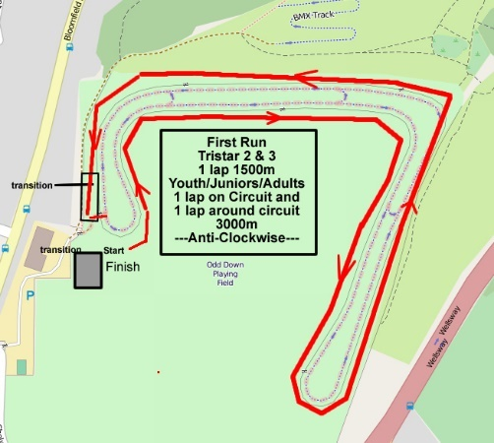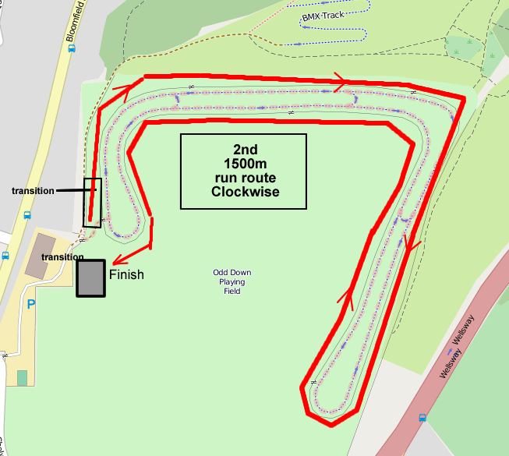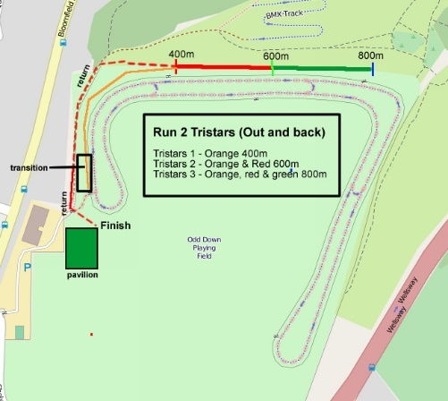

The Tri-star 1 first run will start part the way down the playing field on the 1500m course at 1200m point. Athletes will be walked down to this start point.

Please note that part of the run will be on grass and playing fields. Athletes should be aware that there are some tree routes and potential dips, which will be marked with highlight spray paint. Parents please make sure that your child understands where they have to turn around. There will be a cone and marshal to help direct Tri-star athletes on their second runs and a lead bike for both runs. Please be aware that dog walkers may use grass area around the circuit, they will be warned of runners by marshals on the day and have had prior notice of the event.

Transition Area
The Transition area is immediately adjacent to the entrance of the bike track and is on grass. The area will be secured and only athletes will be allowed into the transition. Space in transition is limited so please stay within your area. It will be arranged in sections according to your race category. Please only bring your race bike and equipment that you will use in your race into transition. No parents, coaches or helpers are allowed in transition. Marshals will be available if any child needs help.

Competitors, please ensure that you are familiar with the location of your bike prior to leaving transition and starting the race. The bike out and run out areas will all be clearly marked. It is your responsibility to familiarise yourself with the location of these areas and your finish.

Bike Course
As you exit transition, you will be directed into a filter lane onto the circuit and cycle ANTI-CLOCKWISE. You must mount ‘after the mount line’ marked on the track. Once you have completed your bike laps, you will filter into the marked dismount lane, which is neutralized ‘no overtaking´ and you must dismount your bike, feet on the ground ‘before the dismount line’

Tri-star / Adult Non-drafting races
The adult and Tri-star races are non-drafting races, therefore if you are overtaken you should drop back. The draft zone is 3m wide by 10m. The rules on drafting are available from the British Triathlon website. Please note that the ‘slower’ riders should ride on the left and the faster riders overtake on the right. Please take extreme caution at the two hairpin bends; please use the correct techniques for cornering these sharp bends: 1. Enter the corner wide 2. Adjust your speed prior to entering the corner 3. Stop pedalling and keep your inside pedal up. 4. Aim to pull in closely to the middle (apex) of the corner. 5. Exit the corner wide Please do not overtake on corners unless for safety reasons. Once you have picked your line stick with it, do not deviate from your line and watch out for other riders cornering. The person in front has right of way, in particular when choosing a line around the corners. Only overtake if it is safe to do so. When overtaking shout to the rider in front “overtaking on your right”, to let them know you are there.

Youth and Junior Drafting races
The Youth and Junior races are draft legal. You will only be allowed to race with a bike that conforms to the draft legal requirements listed below. You must ride within your technical capabilities and at a speed that you are in control of your bike. Be fully aware of other riders around you whether in a group or individuals and communicate before passing another rider. Be very aware of other riders and use caution on the two hairpin bends. You must maintain your line on the track, look behind before moving on the track and you must not block other riders.

Draft Legal Races  1 Time trial bikes are not permitted  2 Only traditional drop handle bars and brake leavers are permitted, and these must not be excessively angled based on UCI standards  3 Clip on bars and tri bars are not permitted  4 The end of both handle bars must be securely covered and and pluged with bar end caps  5 Wheels must have a minimum of 12 spokes. This means disc and tri spoke type wheels are not permitted.  6 There must be one working brake on each wheel.  7 The bike must be no more than one metre and eighty-five (185) centimetres long and fifty (50) centimetres wide.  8 Athletes must not use seat mounted water bottles. | 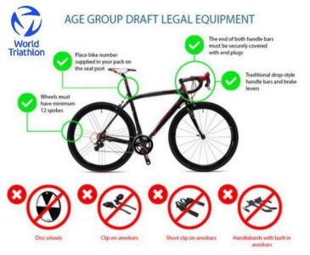

Finish
The finish for the Tristars 1,2 & 3 will be on the track NEXT to the transition area. Please check the map on the website for exact location. The finish for all other categories will be in front of the building under the finish arch. Please collect your bike promptly after you finish your race, when your race category is announced.

Lap Counting
Competitors are responsible for their own lap counting. It is a good idea to have some sort of system to count your laps. The helmet chip will record your lap times but we are unable to tell you the numbers of laps as you are cycling round. If you are found not to have done the correct number of laps the race organizer will adjust your time to give you a result and you will not be eligible for prizes.

Welfare and Safeguarding
Your wellbeing, safety and enjoyment of triathlon is paramount, and you should always feel safe when training and competing. If you are worried, upset or something concerns you like the behaviour of someone, it is important that you can talk to someone that you trust.

Follow these four simple steps:
1 Recognise – if you have a concern, notice a problem or if you are worried or upset
2 Respond – Know what you need to do, identify someone you trust
3 Record – record as many details as possible, who what where, when, capture details in writing
4 Refer – the information to the appropriate people. Do not ignore it – always tell someone!

Stephen Clark is the designated Welfare and Safeguarding Official for this event. Stephen will be located around the start finish area and maybe contacted through the registration desk.
Mobile number: 07901 857050

For any under 16 a responsible adult must be on site during the event and meet their child from the finish. Tristar 1 & 2 children will be held at the finish until they are met by a responsible adult. You are welcome to take photographs of your own children only please. We will be taking photographs for our website. If you do not want your child to appear in these please notify us at registration. A missing Child should be reported immediately to the Registration Desk.

Medical Conditions
Please make sure you have advised us of the correct emergency contact phone number and medical conditions when you entered on-line. These are stored on the computer on the day should we need these in the case of an emergency.

Results
Live results will be available on www.chiptimingresults.co.uk.

Prizes
Prizes will be awarded in each race for Female and Open Categories 1st to 3rd.
Prizes cannot be posted, make sure you stay for the prize ceremony if you think you may have won. In order to maintain low entry prices and to improve the environmental impact of this event, we will not be issuing finishers mementos – we will be planting trees instead!

Youth / Junior Eliminator Race Information
Youth and Junior athletes taking part in the morning individual races will automatically have entry to the Eliminator races in the afternoon. If you are withdrawing from the Eliminator event please make sure that you return your race chip and notify registration after your individual race. If you are racing the eliminator please retain your chip and leave your bike in transition after your individual race.

You will receive a race briefing in transition 10mins before your race start, in order that you can reset your transition. All bikes will be racked facing the same way as this will be required for the flow through transition.

The eliminator races will start with a 400m run on the track into the transition. You must start each run wearing running shoes and change into bike shoes for the bike section (i.e. no running shoes nor duathlon plates or flat pedals may be used as part of the race format is designed to reward fast transitions).

After each run and transition you will complete a single 1.5km lap of the bike circuit, mounting and dismounting at the appropriate lines. The bike course will be draft legal.

Subsequent runs will be a 400m out and back run on grass as per the Tri star 1 run route map.

All athletes will complete the first two run / bikes segments. At the end of the third and fourth runs a percentage of the field (determined and communicated before the race start) will be eliminated from the race.

The final segment of the eliminator race is a 400m run out and back to the finish line.
400m run on track / 1.5km bike 1 x lap of track
400m run on grass / 1.5km bike
400m run on grass / 1.5km bike (Eliminations)
400m run on grass / 1.5km bike (Eliminations)
400m run on grass to finish

A word from our Technical Official Team (Referees) – Jon Shaw (CTO
Do you know the rules? In addition to the draft-legal rules detailed in this race letter, please read the following:

We have listed some general rules to help you when competing in a British Triathlon event. Please remember them as you may be penalised with a time penalty, or even disqualified if you don’t observe British Triathlon Rules (please see British Triathlon website: https://www.britishtriathlon.org/competitionrules

This document aims to acquaint you with the most widely broken rules, so you never have to see or hear from a Technical Official and to hopefully make your race a safe and enjoyable one. If you have any questions please do not hesitate to speak to our Technical Official Team at the race.

General Rules and Race Conduct…
• It is your responsibility as a competitor to know all the rules. As in most walks of life, ignorance is no defense.
• It is your responsibility as a competitor to know and correctly complete the full course of the event.
• Foul and abusive language is not permitted and any failure to obey a marshal, the police or a Technical Official will lead to disqualification.
• Marshals are often volunteers, who help the event team with the running of this. Please respect them and where possible, thank them for their efforts.
• No outside assistance is allowed at any time during your race.
• Please do not use iPods, mobile phones or any other device that may impair your hearing or concentration anywhere on the course (including transition), as this will lead to disqualification.
• When racing, you need to be aware of other competitors and the general public, both on foot and in vehicles. This is however a private venue and a traffic-free race.
• You must wear a bicycle helmet on the bike leg that is of ANSI Z90.4, SNELL B90, EN 1078 or equivalent. A CE mark is not an approved standard. The strap to your helmet must also be snug in its fitting and not altered in any way (definitely not elastic). Helmets will be checked when racking your bike.
• Nudity is not allowed. Competitors must keep their chest covered at all times on the cycle and the run, no matter how hot it is.
• Bikes must be racked on the racking provided using either the seat post, handlebars or brake levers. Bikes must not be racked anywhere else and anybody not racking in this way will be disqualified.
• Remember to place your equipment down, as thrown equipment may interfere with other athletes and lead to a penalty.
• Competitors are not allowed to mark their position in transition with any special device, or flag etc., and must be careful not to interfere with any equipment of other athletes, either deliberately or accidentally.
• Competitors must not remove their bike from the rack until their helmet is fastened. They must not unfasten their helmet until their bike is back in the rack.
• Race numbers must be worn and must be clearly visible at all times. They must not be altered or mutilated in any way as this will incur a penalty.
• You must not mount your bike until advised to do so at the bike mount/dismount line outside of transition. There must be no cycling in transition.

